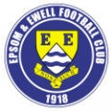 | Epsom & Ewell F.C.  2  v  Horley Town  Monday, 25th August 2014
For our Bank Holiday morning match we welcome our local friends from Horley Town, along with today's match officials, and of course our own regular faces and interested neutrals.

The programme today is a little unusual as it is our first one ever created from 3,000 miles away! Of course, printing deadlines ensured that it would be impossible to get the information from our trip to Colliers Wood included in this transatlantic issue anyway, but there is still time to look back at our other recent matches since we were last here.

We were last at High Road on Tuesday 5th August, where Raynes Park Vale edged us out with a long shot that took a large deflection. On balance we could have been worth a point as we did most of the pressing in the second half, but were unable to get through against a fairly solid team defensively. Clearly their keeper was new to the area, as he asked me in all seriousness how many of our players were on £100 per week!

On Saturday 9th August we travelled to Green Lane, home of Hartley Wintney and met with our first defeat in four visits there. You couldn’t argue with the result, even though it required a late penalty for them to get their winner after Taylor Smith had headed us in front from a right wing Dale Marvell cross.

We also congratulate Lyndon Buckwell on reaching the 400 game mark as a Manager at this game, only the third ever in our club’s history to reach this milestone.

On Saturday 16th we made our first ever visit to the Beacon, home of Hassocks F.C. and bounced back well with a 3-1 win. In the end it was a fairly comfortable victory although at 2-1 we were under a little pressure and coped really well. It was also good to see Dale Marvell back to his best with two goals and an assist, which Taylor Smith met superbly at the far post. The report from that game along with the report from the /colliers /wood match will appear in Saturday’s issue.

This Saturday we are at home to Croydon, who now of course contain Karl Douglin in their ranks. They gave us a tough game in a pre-season friendly and will provide a stiff challenge.

Three days later we are also scheduled to be at home to Chertsey Town in the League, although any Cup replay with Croydon would take precedence, and would be played on the Wednesday so keep checking the website for details.

Enjoy the game!

Rich (Richard.c.lambert@virgin.net) on Twitter @EEFCOfficial

Cover photo this week by Gemma Jarman

Taylor Smith puts us ahead against Hartley Wintney
in our 2-1 defeat there eleven days ago.

Cherry Red Records
Combined Counties League
Premier Division Table 2014/15
inc 16th August 2014 | P | W | D | L | F | A | Pts | GD | H | A
Spelthorne Sports | 4 | 4 | 0 | 0 | 10 | 4 | 12 | 6
Cove | 4 | 4 | 0 | 0 | 8 | 4 | 12 | 4
Mole Valley SCR | 4 | 3 | 1 | 0 | 13 | 5 | 10 | 8
Molesey | 3 | 3 | 0 | 0 | 13 | 2 | 9 | 11
Ashford Town (Mx) | 4 | 3 | 0 | 1 | 7 | 2 | 9 | 5
Bedfont Sports | 4 | 2 | 1 | 1 | 7 | 5 | 7 | 2
Raynes Park Vale | 3 | 2 | 1 | 0 | 3 | 1 | 7 | 2 | 0-1
Camberley Town | 4 | 2 | 0 | 2 | 9 | 3 | 6 | 6
Windsor | 4 | 2 | 0 | 2 | 6 | 4 | 6 | 2
Hartley Wintney | 3 | 2 | 0 | 1 | 4 | 3 | 6 | 1 |  | 1-2
Hanworth Villa | 4 | 1 | 1 | 2 | 5 | 6 | 4 | -1
Badshot Lea | 4 | 1 | 1 | 2 | 3 | 8 | 4 | -5
Epsom & Ewell | 3 | 1 | 0 | 2 | 3 | 3 | 3 | 0
Guildford City | 3 | 1 | 0 | 2 | 5 | 7 | 3 | -2
Colliers Wood United | 4 | 1 | 0 | 3 | 3 | 7 | 3 | -4
Chertsey Town | 4 | 1 | 0 | 3 | 5 | 15 | 3 | -10
Horley Town | 3 | 0 | 2 | 1 | 4 | 6 | 2 | -2
Frimley Green | 4 | 0 | 2 | 2 | 6 | 9 | 2 | -3
Knaphill | 4 | 0 | 2 | 2 | 2 | 9 | 2 | -7
Westfield | 4 | 0 | 1 | 3 | 0 | 7 | 1 | -7
Farnham Town | 4 | 0 | 0 | 4 | 1 | 7 | 0 | -6 |  | 2-0

Lucky Day? – 25th August
Played 21 - Won 7 Drawn 1 Lost 13 - F 23 A 38 - PPG 1.05 - Poor
Club record against today’s opponents
Played 24 - Won 19 Drawn 3 Lost 2 - F 55 A 21 - PPG 2.50 - Fantastic
Last visit
28th December 2013 - Won 5-3 - Combined Counties League

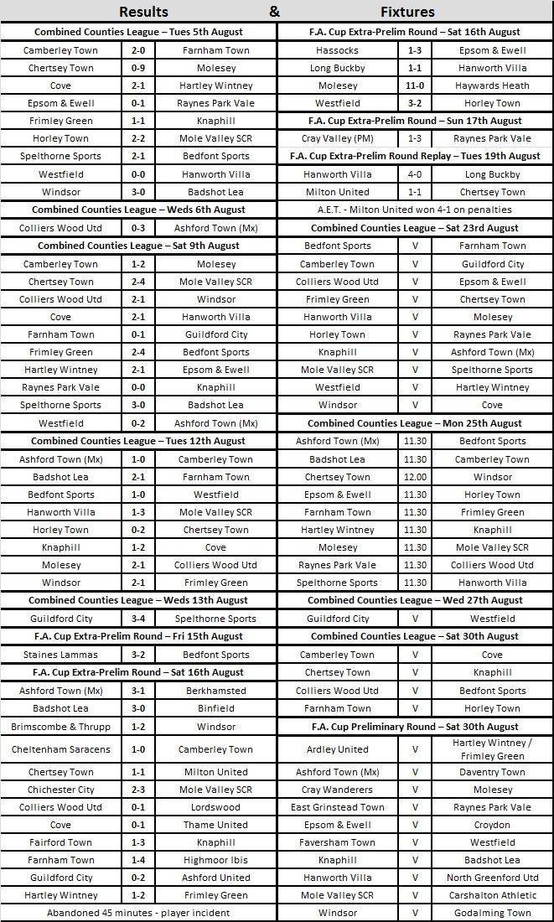
First Eleven Appearances - (max 4 inc Hassocks)
Name |  | Debut | 2013/14 |  |  |  | Career Totals
 |  |  | App | Sub | Total | Goals | App | Sub | Total | Goals
CURRIE Sam |  | 04/08/2012 | 2 | 0 | 2 | 0 | 96 | 5 | 101 | 2
DEAN Dan |  | 02/08/2014 | 4 | 0 | 4 | 0 | 4 | 0 | 4 | 0
DEWAR Ali |  | 29/10/2011 |  |  |  |  | 50 | 29 | 79 | 7
DOUGLIN Karl |  | 03/08/2034 | 1 | 0 | 1 | 1 | 41 | 3 | 44 | 14
DOWNS Carl |  | 17/09/2011 | 3 | 0 | 3 | 0 | 93 | 12 | 105 | 2
EACOTT Michael |  | 02/08/2014 | 4 | 0 | 4 | 0 | 4 | 0 | 4 | 0
FARRELL Matt |  | 02/08/2014 | 4 | 0 | 4 | 1 | 4 | 0 | 4 | 1
GAFFNEY Luke |  | 16/08/2014 | 1 | 0 | 1 | 0 | 1 | 0 | 1 | 0
HARPER Tommy |  | 15/04/2014 | 1 | 0 | 1 | 0 | 2 | 1 | 3 | 0
HAYWARD Ben |  | 07/03/2007 | 2 | 0 | 2 | 0 | 238 | 28 | 266 | 18
HOADLEY Harry |  | 15/04/2014 | 2 | 1 | 3 | 0 | 3 | 1 | 4 | 0
HOUGH Kyle |  | 14/08/2007 | 3 | 0 | 3 | 0 | 257 | 12 | 269 | 137
JARMAN Mark |  | 08/08/2009 | 0 | 2 | 2 | 0 | 131 | 48 | 179 | 76
LEDIJU Richard |  | 13/08/2013 |  |  |  |  | 0 | 9 | 9 | 0
MARVELL Dale |  | 15/01/2000 | 2 | 1 | 3 | 2 | 252 | 41 | 293 | 82
McKAY Alex |  | 20/12/2008 |  |  |  |  | 65 | 22 | 87 | 7
MURPHY George |  | 28/03/2013 | 0 | 1 | 1 | 0 | 41 | 5 | 46 | 2
MUTIMA Lionel |  | 05/08/2014 | 1 | 1 | 2 | 0 | 1 | 1 | 2 | 0
MYERS Antony |  | 23/12/2006 |  |  |  |  | 75 | 33 | 108 | 9
NELMES Elliott |  | 05/08/2014 | 2 | 0 | 2 | 0 | 2 | 0 | 2 | 0
PANAYI Anthony |  | 14/11/2010 | 4 | 0 | 4 | 0 | 131 | 14 | 145 | 4
PIERSON Matte |  | 09/10/2013 |  |  |  |  | 4 | 0 | 4 | 0
ROBINSON Sam |  | 22/10/11 | 1 | 0 | 1 | 0 | 25 | 3 | 28 | 5
SMITH Matt |  | 08/08/2009 |  |  |  |  | 91 | 42 | 133 | 10
SMITH Taylor |  | 02/08/2014 | 4 | 0 | 4 | 2 | 4 | 0 | 4 | 2
TANTON Matt |  | 02/08/2014 | 1 | 0 | 1 | 0 | 1 | 0 | 1 | 0
TAYLOR James |  | 26/08/2013 | 1 | 0 | 1 | 0 | 18 | 6 | 24 | 1
TOUGH Ryan |  | 21/04/2014 |  |  |  |  | 0 | 1 | 1 | 0
URBANSKI Marcus |  | 21/04/2014 |  |  |  |  | 0 | 1 | 1 | 0
VAN GELDER Julian |  | 12/09/2006 | 0 | 1 | 1 | 0 | 0 | 2 | 2 | 0
WHITE Sean |  | 02/08/2014 | 1 | 1 | 2 | 0 | 1 | 1 | 2 | 0
 | Club Directory
ASHFORD TOWN (Mx) Telephone: 01784-245908 - Ground: The Robert Parker Stadium, Short Lane, Stanwell. TW19 7BH - Colours: Tangerine & White Stripes/Black/Tangerine

BADSHOT LEA Telephone: 01252-320385 - Ground: Ash United FC, Shawfield Stadium, Youngs Drive, Shawfields Road, Ash, Hampshire. GU12 6RE - Colours: Claret/White/Claret

BEDFONT SPORTS Telephone: 0208-831-9067 - Ground: Bedfont Sports Club, Hatton Road, Bedfont, Middx TW14 8JA - Colours: Red & Black Hoops/Black/Red & Black Hoops

CAMBERLEY TOWN Telephone: 01276-65392 - Ground: Krooner Park, Wilton Road, Camberley, Surrey. GU15 2QW - Colours: Red & White Stripes/Blue/Red

CHERTSEY TOWN Telephone: 01932-561774 - Ground: Alwyns Lane, Chertsey, Surrey. KT16 9DW - Colours: Royal Blue & White Stripes/Royal Blue/Royal Blue

COLLIERS WOOD UNITED Telephone: 0208-942 8062 - Ground: Wibbandune Sports Ground, Lincoln Green, Opposite 199-213, Robin Hood Way, Wimbledon. SW20 0AA - Colours: Blue & Black Stripes/Black/Black

COVE Telephone: 01252-543615 - Ground: Oak Farm Fields, 7 Squirrel Lane, Cove, Farnborough, Hampshire. GU14 8PB - Colours: Yellow/Black/Yellow

EPSOM & EWELL Telephone: 01737-553250 - Ground: Chipstead FC, High Road, Chipstead, Surrey. CR5 3SF - Colours: Royal Blue & White Hoops/Royal Blue/Royal Blue & White Hoops

FARNHAM TOWN Telephone: 01252-715305 Ground: Memorial Ground, Babbs Mead, West Street, Farnham, Surrey. GU9 7DY Colours: - Claret & Sky Blue /White/ Claret & Sky Blue

FRIMLEY GREEN Telephone: 01252-835089 - Ground: Frimley Green Recreation Ground, Frimley Green Road, Frimley Green, Camberley, Surrey. GU16 6JY - Colours: Blue & White/Blue/Blue

GUILDFORD CITY Telephone: 01483-443322 - Ground: The Spectrum, Parkway, Guildford, Surrey. GU1 1UP - Colours: Red & White Stripes/Black/Black

HANWORTH VILLA Telephone: 0208-831-9391 - Ground: Rectory Meadows, Park Road, off Hounslow Road, Hanworth, Middlesex. TW13 6PN - Colours: Red & White Stripes/Black/Black

HARTLEY WINTNEY Telephone: 01252-843586 - Ground: Memorial Playing Fields, Green Lane, Hartley Wintney, Hants RG27 8DL - Colours: Orange & Black/ Orange /Orange

HORLEY TOWN Telephone: 01293-822000 - Ground: The New Defence, Anderson Way, Court Lodge Road, Horley, Surrey. RH6 8SP - Colours: Claret & Sky Blue/Claret/Claret

KNAPHILL Telephone: 01483-475150 - Ground: Brookwood Country Park, Redding Way, Lower Guildford Road, Knaphill, Surrey. GU21 2AY - Colours: Red/Black/Red

MOLE VALLEY SCR Telephone: 01932-866386 - Ground: Cobham FC, Leg O’Mutton Field, Anvil Lane, Downside Bridge Road, Cobham, Surrey KT11 1AA - Colours: Yellow/Black/Black

MOLESEY Telephone: 0208-979-4283 - Ground: 412 Walton Road, West Molesey, Surrey KT8 2JG - Colours: White/Black/Black

RAYNES PARK VALE Telephone: 020-8540-8843 - Ground: Prince Georges Playing Field, Grand Drive, Raynes Park, London. SW20 9NB - Colours: Blue/Blue/Red

SPELTHORNE SPORTS Telephone: 01932-961055 - Ground: Spelthorne Sports Club, 296 Staines Road, Ashford Common, Ashford, Middx. TW15 1RY - Colours: Light & Dark Blue/Dark Blue/Light Blue

WESTFIELD Telephone: 01483-771106 - Ground: Woking Park, Kingfield Road, Woking, Surrey. GU22 9BA - Colours: Yellow/Black/Black

WINDSOR Telephone: 01753-860656 - Ground: Stag Meadow, St Leonards Road, Windsor, Berks SL4 3DR - Colours: Red/Red/Red

From behind the goal
Epsom & Ewell 0-1 Raynes Park Vale – Combined Counties League
Tuesday 5th August 2014

Salts left sour after deflected winner
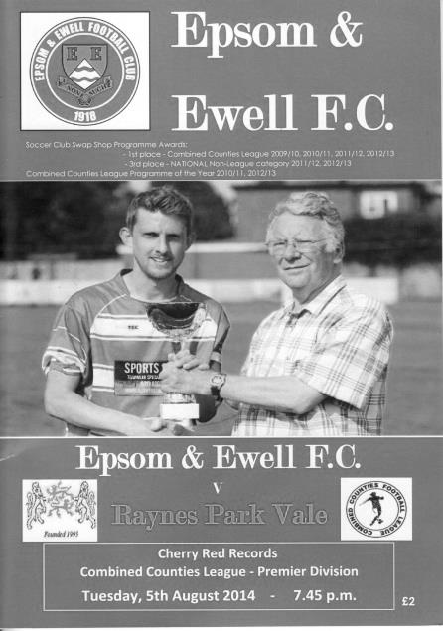
A 28th minute strike from distance by Simon Moore that took a huge deflection was the difference between the sides at High Road on Tuesday.

Following Saturday's win, Lyndon had to reshuffle the pack significantly after losing last season's Player of the Year Karl Douglin to Croydon, Carl Downs to a family gathering and Kyle Hough to a groin injury. In their places came Harry Hoadley, Sean White and Tommy Harper, while at left back, Elliott Nelmes made his debut in place of Matt Tanton.

Before the game there was a presentation to Lyndon Buckwell to mark his upcoming milestone of 400 games in charge, and there was also an award to Mark Jarman as last year's Players Player of the Year. He was also on the bench today as was another returning legend in Dale Marvell, and both would get a run out later on.

Nelmes was only just wide with an early free kick while the visitors dragged a couple of long shots wide. It already looked like it may be a game with few clear cut chances and Harper lashed the ball wide from a good position just inside the penalty area after 25 minutes.

This was followed by a great strike from Matt Farrell, but was met by an equally great save by Sam Fuller, who palmed the ball away for a corner at full stretch. From that corner Dan Dean met the ball at the far post but was unable

to keep the attempt on target.

We were beginning to get into our stride but against the run of play the visitors took the lead. The situation may have appeared harmless, but Simon Moore, who seems to score against us every time he plays, decided to try his luck from distance, and his luck was in as his shot cannoned off Ato Okai and into the opposite corner with Michael Eacott fully committed to the shot in the opposite direction. Under the circumstances he did really well to even get a hand on the ball but couldn't keep it out.

Although little else happened up to half time most of the action was in our half as we seemed to lose our way a bit. An injury to Harper slowed him down a bit and he was replaced by the recently retired Jarman at half time.

Unfortunately, despite raising our game in the second half, it was bitty and play was regularly stopped as a result of niggly fouls for which three yellow cards were awarded. We got forward after 74 minutes when Nelmes' deep cross was headed back across goal by Sam Currie, but the ball went just beyond the far post.

The best chance of the entire game fell to Taylor Smith when a pass from Jarman seemed to go through a defender. Maybe Smith wasn't expecting to receive the ball and he poked at the chance left footed, sending it wide. I felt we were worth a point today, but didn't do enough over the ninety minutes to warrant anything more.

Line Up: Michael Eacott, Sam Currie (capt), Elliott Nelmes, Anthony Panayi, Dan Dean, Harry Hoadley, Ben Hayward, Sean White, Taylor Smith, Tommy Harper, Matt Farrell
Subs: Mark Jarman for Harper (45), Dale Marvell for Hayward (71), Lionel Mutima for Nelmes (74)

Club Records - 25th August
Date | Day | Competition |  | Opponents |  | Scorers
25/08/28 | Sat | Friendly | H | Rest of the  London League | 3-0 | R.Marlow (2), J.Parr
25/08/34 | Sat | London League | H | P.O.Engineers | 0-2
25/08/51 | Sat | Corinthian League | H | Hounslow Town | 0-2
25/08/56 | Sat | Corinthian League | H | Tilbury | 1-0 | D.Hermitage
25/08/62 | Sat | Corinthian League | H | Uxbridge | 0-2
25/08/65 | Wed | Athenian League 2 | H | Croydon Amateurs | 1-3 | A.Cox
25/08/70 | Tue | Athenian League 2 | H | Worthing | 0-3
25/08/75 | Mon | Athenian League 2 | H | Eastbourne Town | 3-0 | P.Walker (2), T.Algar (pen)
25/08/79 | Sat | Isthmian League 1 | A | Ware | 4-2 | T.Tuite (2, 1 pen), R.Beswick, T.Pommell
25/08/80 | Mon | Isthmian League Cup 1 | A | Rainham Town | 4-1 | T.Tuite (2), D.Walker, F.Samoth
25/08/81 | Tue | Isthmian League 1 | H | Tilbury | 1-0 | P.Gaydon
25/08/84 | Sat | Isthmian League Premier | H | Hayes | 1-3 | S.Milton
25/08/87 | Tue | Isthmian League Cup Preliminary Round | A | Hemel Hempstead F.C. | 0-2
25/08/90 | Sat | Isthmian League 2s | H | Egham Town | 1-3 | T.Tweedy
25/08/92 | Tue | Isthmian League 3 | H | Camberley Town | 0-3
25/08/95 | Fri | FA Cup  Preliminary Round | H | Tooting & Mitcham United | 0-4
25/08/98 | Tue | Isthmian League Cup Preliminary Round | A | Abingdon Town | 1-2 | K.Webb
25/08/01 | Sat | Isthmian League 3 | H | Wingate & Finchley | 0-1
25/08/03 | Mon | Isthmian League 1s | H | Croydon Athletic | 1-1 | S.Huckle
25/08/07 | Sat | Combined Counties  Premier Division | A | Wembley | 0-3
25/08/08 | Mon | Combined Counties  Premier Division | A | Egham Town | 2-1 | R.Burns (2)
90 years ago – Epsom Town
30/08/24 | Sat | Friendly | H | Dorking | 1-3 | S.Bristow (pen)
80 years ago – Epsom Town
25/08/34 | Sat | London League | H | P.O.Engineers | 0-2
60 years ago – Epsom F.C.
21/08/54 | Sat | Corinthian League | H | Tilbury | 5-2 | B.Avis (2), B.Musto (2), B.Canham
50 years ago – Epsom & Ewell F.C.
26/08/64 | Wed | Athenian League 1 | H | Eastbourne | 2-6 | N.Dearlove, T.Higgins
40 years ago – Epsom & Ewell F.C.
27/08/74 | Tue | Surrey Senior League | H | Horley Town | 2-0 | T.Lee, T.Tuite
30 years ago – Epsom & Ewell F.C.
25/08/84 | Sat | Isthmian League Premier | H | Hayes | 1-3 | S.Milton
20 years ago – Epsom & Ewell F.C.
23/08/94 | Tue | Isthmian League Cup Preliminary Round | H | Hornchurch | 0-0
10 years ago – Epsom & Ewell F.C.
28/08/04 | Sat | Isthmian League 2 | H | Abingdon Town | 5-4 | R.Ingham (2), M.Owen (2), C.Read

History Corner – 25th August
This is the sixteenth time in twenty-two matches that we have played at home on this date!

90 years ago this week the Epsom Town club came of age. After six years they had worked their way up through Junior and Intermediate ranks to play with the other Senior status clubs in the Surrey Senior League. It was to be an exciting season with an entry into the Amateur Cup for the first time, although they would have to wait a season before being allowed into the F.A. Cup.

This day’s opening match of the season was listed as a Friendly, but what we know now as friendlies were known back then as Trials. “Friendlies” were equally competitive and were included by the club as official matches up until 1960, so who am I to argue? Unfortunately, due to other sporting commitments our two real stars, the Sperring twins, would miss this home match against Dorking at the Horton Hospital Grounds, and we were defeated 3-1.

80 years ago this week Epsom Town were involved in the traditional curtain raiser to the season, where they competed against a representative side comprised of the best that the League could offer. On this occasion it was not very much and the London League winning Town cruised to a 3-0 victory with two goals from Reg Marlow and the other from Jack Parr. However, we would never win the London League again, becoming runners up on five occasions in the thirties.

40 years ago this week we met today’s opponents, Horley Town and defeated them with two second half goals from Trevor Lee and Tommy Tuite. This was our fourth straight win of the season and we had scored 16 with zero conceded to this point.

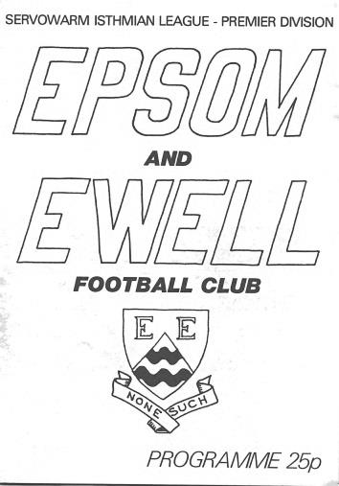
30 years ago today we took on the big boys as we made our bow in the Premier Division of the Isthmian League. (see programme right) Hayes were the opponents and although they won 3-1 that day, Despite being a youngster back then, I remember feeling that we had been unlucky to lose and that everything would turn out fine. It did, in the end, but we would have to wait until November before we would win a League match!

10 years ago this week Abingdon Town visited Merland Rise for an Isthmian League Division Two match and took an early two goal lead, but we were level soon after and despite conceding again, it was 3-3 at the half. We then went ahead but former Oxford United and West Ham player Joey Beauchamp scored his second goal to bring the visitors level, before Richard Ingham rode several challenges to clip in the winner after 78 minutes and the 5-4 result put us top of the table. It wouldn’t last, and we ended up in the bottom three!

6 years ago today two goals from Robbie Burns, the second an audacious back flick, earned us a 2-1 win at Egham Town in a League match.

Centre page for results

Centre page for results

Horley Town – History
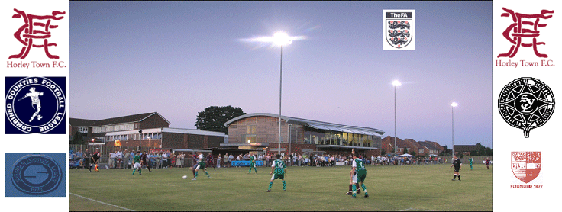
Horley Town Football Club were founded in 1898 to provide football for the local community. From its early days the aim has not changed, it still provides for healthy competition from boys and girls aged seven through to senior status. From junior football there has always been a team capable of competing in whatever league it was playing in. The club progressed from junior football for its first team to intermediate and eventually on to senior status. At senior level the club were members of the Surrey Senior League and progressed to the old Spartan League in 1979. From here after winning the league, the club progressed in 1981 to the old Athenian League.

After a few years in the doldrums the management committee decided, with the full backing of the members to take stock of where the club was and in 1997 it was decided to go back to junior football in the Crawley and District League, thus allowing a chance to bring on a crop of outstanding youngsters through to the senior team, and the majority of whom are still with the club today.

A successful year in 2001 saw the first team win the Crawley League and Charity Cup, which led the management committee to decide that with the youth set up in place it was now the right time to return to senior football, and were promoted to the Surrey Senior League. From here the club was then accepted into the Combined Counties League in 2002.

During this time we also moved into our new state of the art ground called The New Defence and it is with thanks to past and present management committee members that this has been possible as without all their hard work behind and in front of the scenes this could never have been achieved, and is something we can all be proud of.

After the first couple of years finding our feet at this level the team has progressed well, and this season under the management team led by Mark Gilbert and assisted by Graham Rashbrook will move on the excellent ground work formed within the youth set up, and are committed to producing where possible our own youngsters. The reserves play in the Suburban Football League under the direction of Colin Poplett, the Youth team play in the Southern Youth League under Anthony Jupp and John Eldred, and the third team play in the Redhill and District Premier Division under the management of Mark Sale and Mark Aglim.

On Sundays, Horley Town has no less than 26 teams competing in various leagues from under 7 to under 17 and this has and always will be the way forward for us, bringing through our own talent and providing for the future. Horley Town also boast 2 senior ladies teams. We are lucky to have committed managers and players within our junior set up that make this happen, and our thanks go out to them.

The club has a committed five-year programme to provide facilities capable of entering the very best football competitions outside of the football league, and with the New Defence it only bodes well for the future of such an old established club. On the social front the membership amounts to over 450 many of these with family memberships, swelling the numbers considerably.

Last season Horley escaped relegation on the final day of the season when drawing 4-4 with Mole Valley SCR.

From behind the goal
Hartley Wintney 2-1 Epsom & Ewell – Combined Counties League
Saturday 9th August 2014

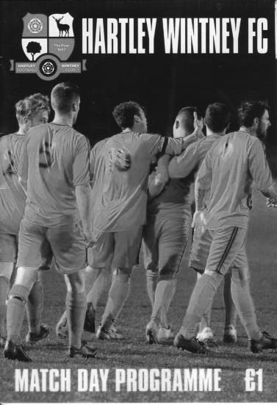
Eacott heroics are in vain as Salts are defeated at Green Lane

A quite brilliant display of goal keeping from Michael Eacott nearly ensured that the Salts came away from Hartley Wintney with a point, but a penalty awarded twelve minutes from time ensured that the hosts claimed the three points they deserved.

With Captain Sam Currie absent, Anthony Panayi became almost certainly our second youngest Captain in club History but was unable to inspire an Epsom side that appear to be feeling a bit sorry for themselves right now.

The opening exchanges were fairly even although Harry Hoadley required a few minutes on the side-line to get over an early injury. Once back on the field though we nearly conceded when Hollamby produced a "cuff turn" and broke through on goal, with only a defender's leg preventing Eacott from being involved after 12 minutes.

We took a few minutes of home pressure but came out the other side and went ahead after 23 minutes when a pinpoint right wing cross from Dale Marvell was headed in by Taylor Smith with the keeper Mahoney being surprised by the prodigious leap from our striker and unable to stop the ball going in.

The home side responded with a nasty foul on Hough that earned Walsh a booking, and he was replaced a few minutes later. After 34 minutes the home side registered their first shot on target from a free kick, given away by a clumsy and unnecessary defensive challenge on the edge of the area. The free kick was low and bobbled in front of Eacott, but he kept his eye on it and knocked it wide and the ball was then cleared.

The game began to swing more in favour of the hosts from this point and Eacott was required to stop a low shot from close range before they equalised in the 43rd minute. Kyle Hough was defending on the edge of our area and fouled his man. From Walker's free kick, the centre half Noakes was there to head past Eacott from
six yards out. It was a god delivery, but no one appeared to pick him up which was

a disappointing way to end the half, but it could have been worse had a volley from inside the box been kept down.

Unfortunately, the second half continued in a similar vein, despite our boys going downhill. Eacott denied the home side with a fine save to his left from a shot twenty yards out that came through a crowd of players. Moments later we had a chance on the left when Smith broke the offside trap and was clearly going to reach the ball ahead of the committed Mahoney, but instead of rounding him, he chose to cut the ball back to Matt Farrell whose effort was blocked on the edge of the area. Two minutes later Farrell returned the favour but Smith's low shot was well saved.

We caused them problems after 68 minutes when Hough's right wing cross was knocked goalwards by defender Noakes but it didn't cause too much trouble and shortly afterwards they were pushing us back again, with only Dan Dean getting a good block in of a powerful shot. However, after 72 minutes Elliott Nelmes was injured on the left and we struggled for a while with ten men before he was replaced. Eacott made three fantastic saves in quick succession to deny the hosts. Moments after this Julian Van Gelder came on in his place while Sean White replaced Carl Downs as we reverted to a 4-4-2 formation.

Whether it was working or not is hard to say as within a minute we had lost the game. A high ball over to the side of our penalty area was headed away by Dean. Unfortunately he had gone straight through Hollamby to get there and it was an easy decision for the referee to give the penalty, which was converted by Stephens after 78 minutes. This had been coming and a few challenges by our defenders in this match and the two previous ones had caused concern that one of them might shortly occur in the area.

As the game concluded Marvell got in a good position but seemed unable to make up his mind whether to shoot or cross and his ball went across goal and out. Also Taylor Smith nearly had his Gareth Bale moment when from five yards outside the area he cut onto his left foot and fired a shot that bounced up and out to safety off the Hartley crossbar, but it would have been really harsh on the home side who were fully deserving of this win. For our part, we need to pick ourselves up, realise that Douglin isn't coming back and find a way of dealing with it.

Line Up: Michael Eacott, Lionel Mutima, Elliott Nelmes, Anthony Panayi (capt), Dan Dean, Carl Downs, Dale Marvell, Harry Hoadley, Taylor Smith, Kyle Hough, Matt Farrell

Subs: Julian van Gelder for Nelmes (76), Sean White for Downs (76)

Every Opponent A-Z
Over the years we have played many, many different opponents. Exactly how many is a difficult question, as it all depends on your definition. Are Camberley & Yorktown different to Camberley Town, or are Epsom Town different to Epsom F.C. or Epsom & Ewell F.C.?

In my analysis I have classed them as the same team, and will work through them all from A to Z. Some we have played many times, whilst others we have met maybe just once or twice. Enjoy!

Leavesden: Played 18 – W5 D3 L10 - F39 A50 - PPG - 1.00 - Poor

The first team to actually play against Leavesden was our Reserves, as in 1928/29 season, Leavesden Mental Hospital as they were then known, spent five seasons in the First Division of the London League. We did not fare well against the Hertfordshire side, losing nine of the ten matches we played; our solitary win of 3-2 coming on 17th October 1931. Upon promotion to the London League Premier Division they gave our first team a similarly torrid time and were a tough opponent from 1933/34 until 1949.

Based between Leavesden and Abbots Langley, near Watford, we had an affinity towards them due to the similar landscape surrounding our town, although theirs was on a grander scale than any individual hospitals we had in Epsom. Quaintly referred to by the Metropolitan Asylums Board as suited for “quiet and harmless imbeciles” and with an almost identical design to the Caterham Mental Hospital, work started on the building in 1868, although work was slow and it did not actually open until 27th September 1870! The two Hospitals were planned to cater for the North and South of the capital.

The site expanded in 1929 and by this time coupled with the obligatory works football team that had been founded in 1908, they started to compete at a very decent level. The pitch was known as Woodside, so would have been along the east side of the building which had Woodside Road as a boundary. The ground was in the shadow of an enormous chimney (see below).

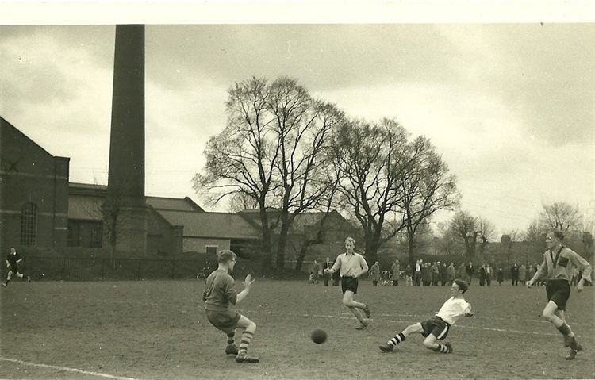
We first played Leavesden Hospital, as they were by now listed in football terms, in February 1934. We had a great team that year and had reached the First Round of the F.A. Cup, yet they thrashed us 5-1 at West Street, completing the double two months later with a 3-1 win at Woodside.

The following season the papers wrote that we gained revenge with a 6-1 win, but this was only due to a five goal burst in the second half after their keeper had broken a finger and been replaced by their star striker, Vale. They then promptly won the next four meetings, scoring at least four on each occasion!

Our wretched record improved slightly with a couple of 1-1 draws and a narrow 3-2 win on 8th January 1938; a match tinged by sadness following the untimely death in a car crash of our former player Jack Parr a few days previously. We also won 2-0 at West Street in the final midweek match of the 1938/39 season, which proved to be the last midweek evening match at the venue for over six years.

We restarted after the War and found Leavesden as regular opponents once again. The most memorable of these meetings came on 21st February 1948 when we travelled for a League match despite heavy snow which had rendered almost every other game off in the South East, so it must have been bad! Probably because of the conditions, only eight men travelled to Woodside and Secretary Harry Hawke thought quickly and signed on three players from the crowd, R.Dean, D.Goldsack and D.Lines. Dean was a former full back before the war while the other two were little more than schoolboys, although Goldsack senior had been a regular scorer for the club in earlier days.

Despite all of this fuss, we nearly won the game! In fact we had a “winning” goal ruled out by the referee after consultation with a linesman and insult was then added to injury as the home side went up the other end and scored their own winner instead, losing 3-2 in the end, all played on a carpet of snow!

We didn’t know it at the time but only had two more meetings left and we would win them both, finally registering our first win at Leavesden at the ninth attempt by two goals to one on 22nd January 1949 and seven days later, winning by the more comfortable score of 5-1. That summer we moved to the Corinthian League and never met again.

Leavesden remained in the top flight of the London League until 1954/55 when they were relegated after a disastrous season that ended with just four points and then kicked around in the Hertfordshire County League until folding in the late eighties. Kings Langley then used the ground for a little while.

The site was closed in 1995 with many buildings demolished. A Country park now covers the site although football continues to be played there. The building pictured below was the Administration block and is still in existence today.

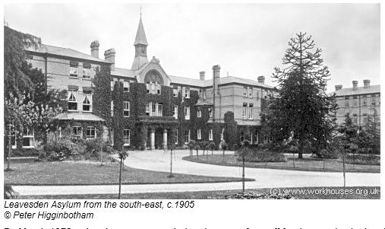

Match and Ball Sponsorships – 2014/15
Opponent | Date | Match Sponsor | Ball Sponsor
Raynes Park Vale | 05/08/14 | Club President - Stella Lamont
Horley Town | 25/08/14 | Epsom & Ewell F.C. Management Committee
Croydon (FAC) | 30/08/14
Chertsey Town | 02/09/14
Frimley Green | 13/09/14 | Provisional and dependent on Cup progress
(F.A. Cup 1q) | 13/09/14 | Provisional and dependent on Cup progress
Guildford City | 30/09/14
Mole Valley SCR | 07/10/14
Bedfont Sports | 11/10/14
Knaphill (LC) | 14/10/14
Ashford Town (Mx) | 18/10/14
Spelthorne Sports | 11/11/14
Molesey | 22/11/14 | Provisional and dependent on Vase progress
Hanworth Villa | 06/12/14
Windsor | 03/01/15
Farnham Town | 17/01/15
Westfield | 31/01/15
Camberley Town | 07/02/15
Hartley Wintney | 21/02/15
Cove | 07/03/15
Badshot Lea | 21/03/15
Colliers Wood United | 04/04/15
Knaphill | 18/04/15
For League Matches:

Match sponsorship - £40.00 Match ball sponsorship - £25.00.
Combined Offer of Match and Match Ball sponsorship for £55.00.

For Cup Matches:

Match sponsorship - £50.00 Match ball sponsorship - £30.00.
Combined Offer of Match and Match Ball sponsorship for £65.00.
----------------------------------------------------------------------------------------------------------------
Sponsorship includes

Admission, programmes, advertising (if required) and hospitality.

If you are interested, just speak to a Committee Member, you know where we are!
Alternatively, drop an email to richard.c.lambert@virgin.net

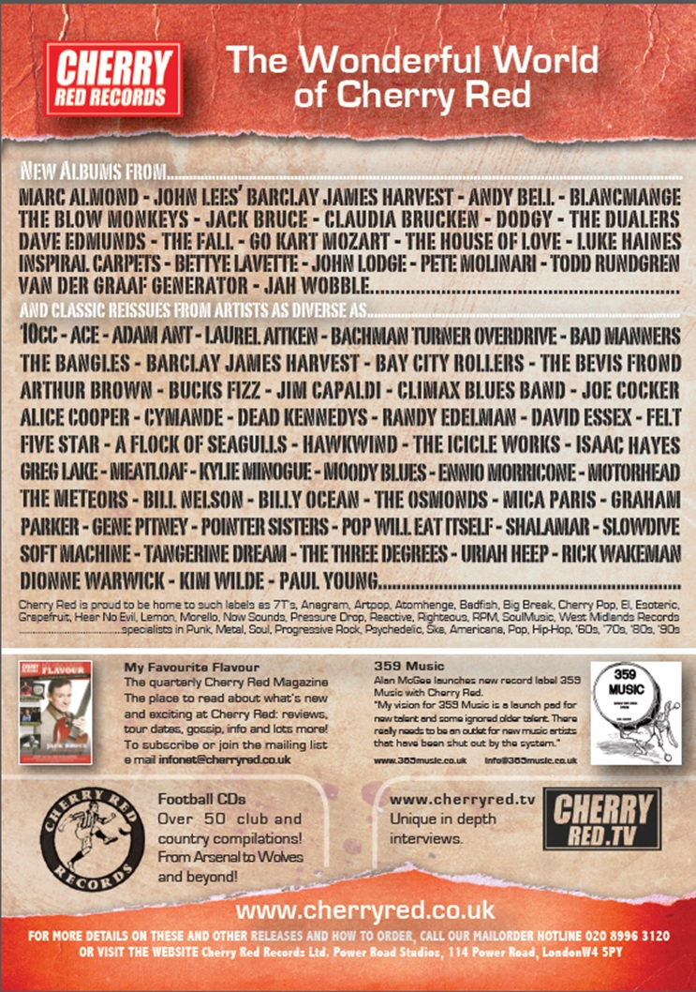

Combined Counties League – Premier Division
Monday, 25th August 2014 - Kick-off 11.30 a.m.
Epsom and Ewell  (Royal Blue & White hoops) | V |  | Horley Town  (Claret and Blue)
 | NUMBERS
Michael Eacott |  |  | George Hyde
Luke Gaffney |  |  | Jack Poplett
James Taylor |  |  | Charlie West
© Anthony Panayi |  |  | Kayode Conteh
Dan Dean |  |  | Tom Winsor ©
Harry Hoadley |  |  | Ben Herdman
Carl Downs |  |  | Adam Pullin
Dale Marvell |  |  | Charlie Smith
Taylor Smith |  |  | Ashley Nadesan
Kyle Hough |  |  | Liam Giles
Matt Farrell |  |  | Corbin Turner
Sam Robinson |  |  | Mick Sullivan
Matt Tanton |  |  | Dan Nayson
Lionel Mutima |  |  | Nathan Jupp
Ben Hayward |  |  | Joe Brown
Richard Lediju |  |  | George Branton
George Murphy |  |  | Gary Tomlinson
Ali Dewar
Elliott Nelmes
Lyndon Buckwell | MANAGER |  | Anthony Jupp
Glyn Mandeville | ASSISTANT
Tony Coombe | CHIEF SCOUT
Matt Smith | COACH |  | Chris Weller
Ken Jones | PHYSIO |  | Gail Selby
REFEREE: A.Lewis (Tooting)
ASSISTANTS: R.Wells (Coulsdon), R. van Niekerk (Sutton)
Today’s Match and Match Ball are sponsored by
the Epsom & Ewell FC Management Committee

OUR NEXT VISITORS TO HIGH ROAD

Croydon

Saturday 30th August 2014 - Kick-off 3.00 p.m.
F.A. Cup – Preliminary Round

